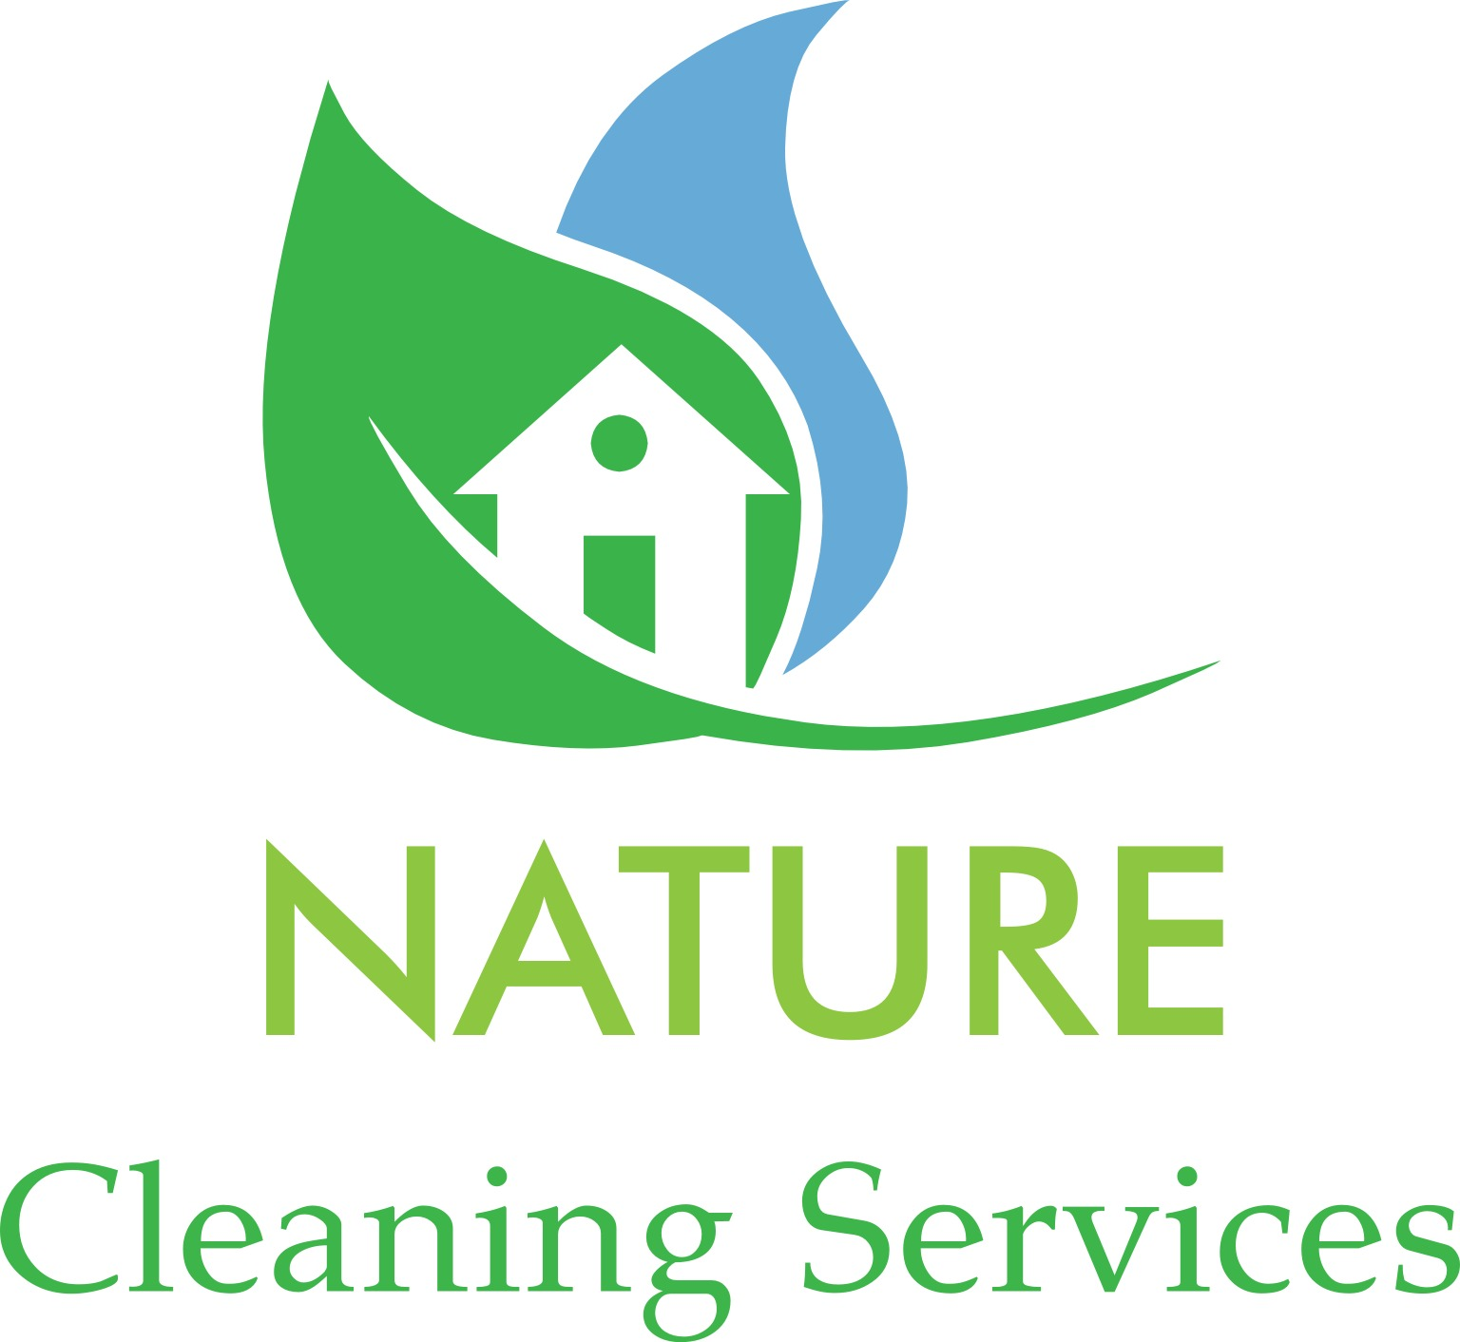
Best Way, Truthful and New Life

Nature signature clean is built around our Checklist. Have something you’d like cleaned that’s not on our list just contact us to go over special needs and requests.
Kitchen
- Appliance exteriors cleaned
- Microwave exterior/interior cleaned
- Tables and chairs cleaned
- Fingerprints removed from all woodwork, door-frames and switch plates
- Countertops and backsplash disinfected
- Cabinet fronts cleaned
- Sinks scrubbed and disinfected
- Floor vacuumed and/or washed
- Windowsills cleaned
- Baseboards dusted
- Trash emptied
Bedrooms
- Lamps cleaned and lampshades dusted
- Fingerprints removed from all woodwork, door-frames and switch plates
- Picture frames dusted
- Furniture dusted
- Floors vacuumed and/or washed (under bed if accessible)
- Windowsills cleaned
- Baseboards dusted
- Trash emptied
- Mirrors cleaned

Bathrooms
- Tub and shower tiles scrubbed, disinfected and rinsed
- Toilets disinfected insides and out
- Chrome fixtures cleaned and shined
- Countertops disinfected
- Cabinet front cleaned
- Sinks scrubbed, disinfected
- Floors vacuumed and/or washed
- Baseboards dusted
- Trash emptied
- Mirrors cleaned

Other Living Areas, including Hallways and Stairs
- Upholstered furniture vacuumed
- Cushions and pillows fluffed and straightened
- Fingerprints removed from all woodwork, door-frames and switch plates
- Ceiling fans dusted (height restriction apply)
- Lamps cleaned and lampshades dusted
- Picture frames dusted
- Furniture dusted
- Hardwood floors vacuumed and/or washed
- Hallways and stairs vacuumed and/or washed
- Carpets vacuumed
- Windowsills cleaned
- Baseboards dusted
- Trash emptied

NatureCleaning@outlook.com

